UTA Logo UCT

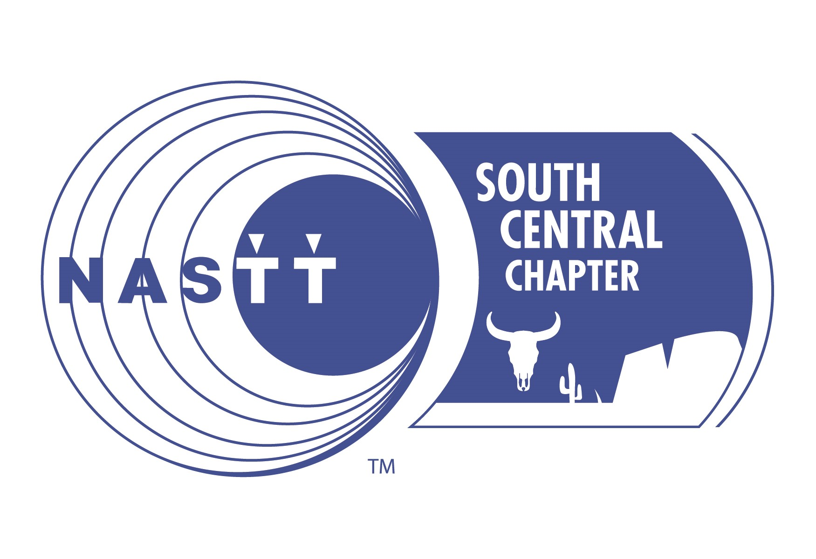

**NORTH AMERICAN SOCIETY FOR TRENCHLESS TECHNOLOGY  
SOUTH CENTRAL REGIONAL CHAPTER   
SCHOLARSHIP APPLICATION**

**DESCRIPTION**

* Founded in 1990, NASTT is an engineering society of individuals, public organizations and private companies with strong beliefs in the practice, social and environmental benefits of trenchless technology. It represents more than 2,000 members throughout USA and Canada who promote better and more responsible ways to manage our underground infrastructure.
* The NASTT South Central Regional Chapter makes up the region of Texas and Oklahoma.
* The South Central Chapter offers **three (3) total scholarships** to be awarded at the NASTT South Central Chapter Event on Tuesday September 25, 2018.
* The South Central Chapter offers **two (2)** of the **three (3)** scholarships to students currently enrolled at OSU or UTA NASTT student chapters in the amount of **$1,500 each** (one-time scholarship).
* The South Central Chapter offers **one (1)** of the **three (3)** scholarships to any high school or college student that has an active family member in NASTT. This student is not required to go to OSU or UTA, but must require an active NASTT family member.
* Scholarship Link- [https://www.nastt.org/about/regional-chapters/south-central/](https://urldefense.proofpoint.com/v2/url?u=https-3A__www.nastt.org_about_regional-2Dchapters_south-2Dcentral_&d=DwMFAg&c=G4BpsyPyB19LB50bn2swXw&r=RsXoCHCmtI4mpsl3sSozNbP7blqF43AQV3UZOTi52-k&m=I3dBK_3poB0i1S4dHoWFC1CthU7euMeTaZnwjVtozvA&s=0w-jjtCJkBuRnqy4DoZ2A8UJ6xoFty0HPRPkaNnGPAM&e=)
* Award payments shall be sent to the recipient’s financial aid office and are to be solely used for paying tuition, fees, books and other education directly related fees for the academic year. Each student is responsible to provide the appropriate contact information for transfer of funds. Monies not utilized for educational purposes shall be returned to NASTT. Students will be contacted in the years following graduation in order to track the success of this program. All applications must submit application to [mgallagher@nastt.org](mailto:mgallagher@nastt.org) by the posted deadline of 11:59 p.m. on **September 7, 2018.**

**ELIGIBILITY**

Applications will be accepted from students who meet the following criteria:

* 2 NASTT student scholarships - applicants must be part of the NASTT student chapter at OSU or UTA.
* 1 NASTT member scholarship - applicant must be a child, grandchild, or sibling of an active NASTT member, or an employee of an active NASTT member organization and resides in the state of Texas or Oklahoma.
* This may be a four-year college, community college, technical or vocational school within the state of Texas or Oklahoma. Applicant must be an undergraduate or graduate student.
* Applications must include an official transcript.
* Applicants must provide a 500-word essay on trenchless technology.

**ESSAY GUIDELINES**

In 500 words or less, please provide an essay based on your choice of the following topics listed below. Essays will be graded on originality, clarity of comments, supporting statements, grammar, spelling and overall impression. The completed essay must be submitted with your application.

* Describe how underground construction and/or trenchless technology interests you as a prospective career choice.
* Describe your impression of the value and the future of the trenchless technology industry.
* Explain how the underground construction industry has helped your community.
* Describe how this scholarship would help you achieve your career goals.

**SELECTION PROCESS**

Applications will be available online and must be 100% compete to be considered. Completed applications will be reviewed by the NASTT South Central Chapter board members. Selections will be based on academic achievement, demonstrated leadership, honors achieved, work experience, goals/aspirations, and interest stated in the underground construction industry.

* Completed applications must be received online by 11:59 p.m. on **September 7, 2018**
* Scholarship award presentation will take place at our annual NASTT/OSU South Central Chapter event in Stillwater, OK on **September 25th, 2018**.

**NASTT SCHOLARSHIP AWARD CHECK LIST**

Completed applications must consist of the following items:

* Scholarship Application Form Submitted Online _____
* Proof of Citizenship (PDF Copy of passport or birth certificate) _____
* 500 Word Trenchless Technology Essay _____
* Photograph (Head & Shoulders Style, high-resolution JPEG image) _____
* Official Educational Institution Transcript (PDF Copy) ____

Additional reminders:

* Are your documents 100% complete? _____
* Is your essay no more than 500 words? _____
* Do you reside in the states of Oklahoma or Texas? _____
* Are you a child, grandchild, or sibling of an active NASTT member, or an employee of an active NASTT member organization? _____
  + Name of active NASTT member: _______________________________________
* Are you a current member of a NASTT Student Chapter at OSU or UTA? _____
* Are you an American or Canadian citizen? _____
* Do you consent to publication usage of your photograph by NASTT? _____
* If selected, are you able to attend the scholarship award presentation which will take place at the NASTT South Central Regional Chapter annual event on September 25th, 2018 at the Oklahoma State University? _____